**SQL ASSIGNMENT**

* **Renusri.K, 2237051**

**Mystery:** A crime has taken place and the detective needs your help. The detective gave you the crime scene report, but you somehow lost it. You vaguely remember that the crime was a **murder​**that occurred sometime on Jan.15**, 2018​and** that it took place in SQL **City.** Start by retrieving the corresponding crime scene report from the police department’s database.

**Queries:**

1. **SELECT \***

**FROM crime_scene_report**

**where date= 20180115**

**AND type="murder"**

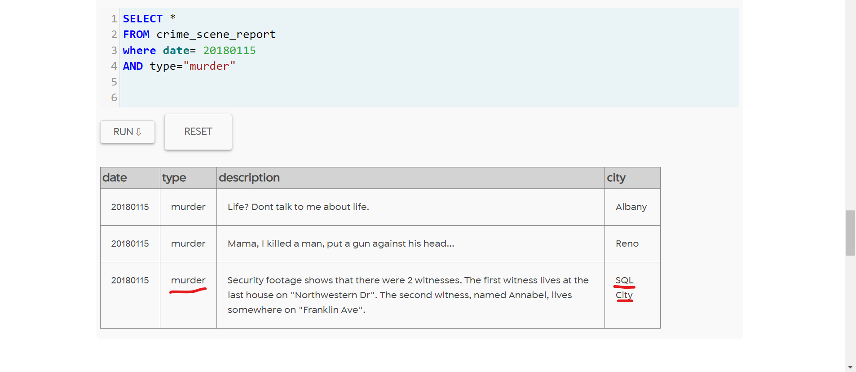

1. **SELECT \***

**FROM person**

**where address_street_name**

**LIKE "Franklin Ave"**

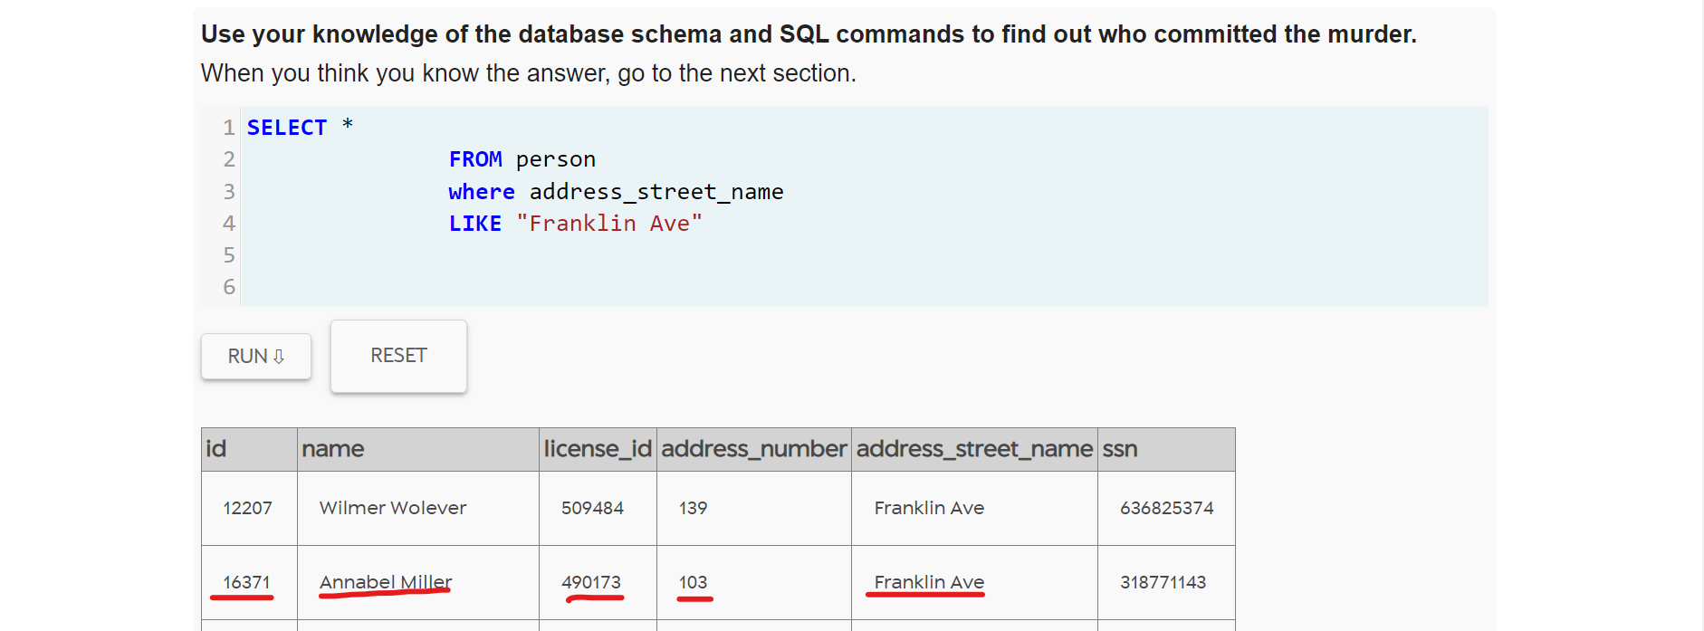

1. **SELECT \***

**FROM person**

**where address_street_name**

**LIKE "Northwestern Dr"**

**Order by address_number DESC**

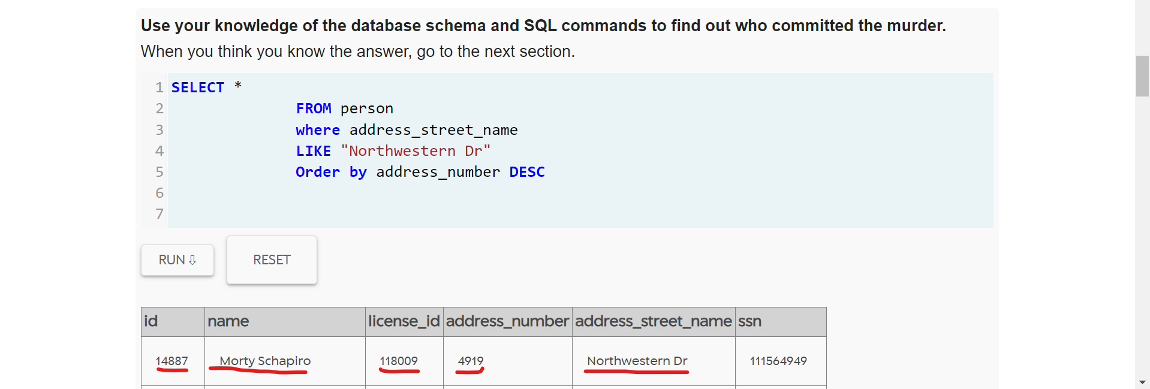

1. **SELECT \***

**FROM interview**

**where person_id=16371**

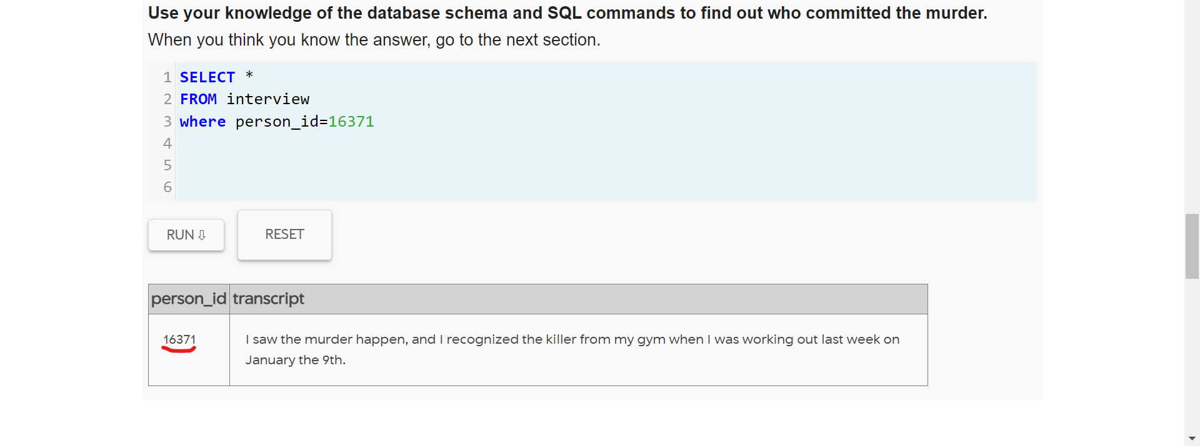

1. **SELECT \***

**FROM interview**

**where person_id=14887**

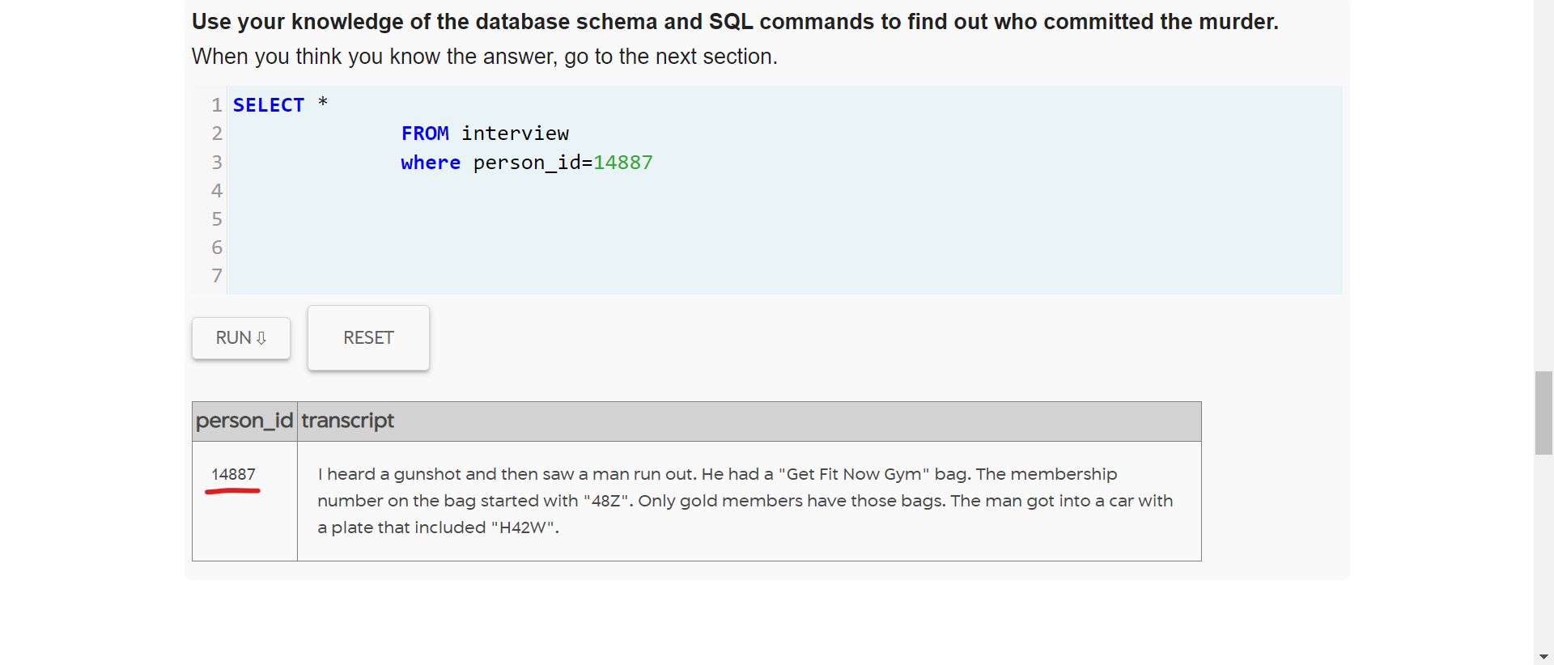

1. **SELECT \***

**FROM get_fit_now_check_in**

**JOIN get_fit_now_member**

**ON get_fit_now_check_in.membership_id = get_fit_now_member.id**

**WHERE membership_id**

**LIKE "48Z%"**

**AND check_in_date=20180109**

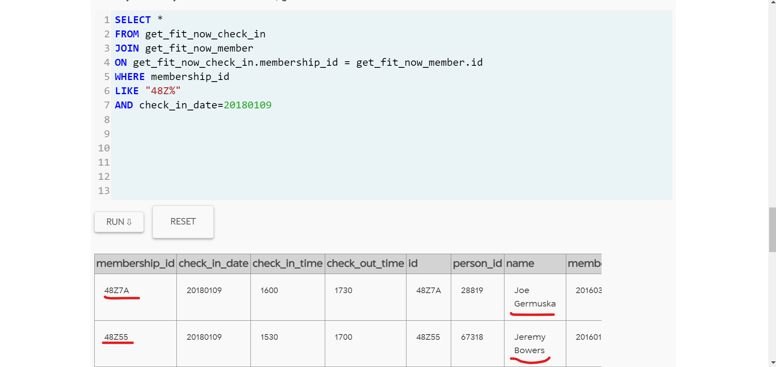

1. **SOLVED MYSTERY**

